Jennifer Ortiz
SPEDE 777

Document Camera for SMART Board

Enables you to:
- Display printed documents
- Microscope slides
- Record Videos
- Scan Documents
- Capture images

Document Camera Modes:
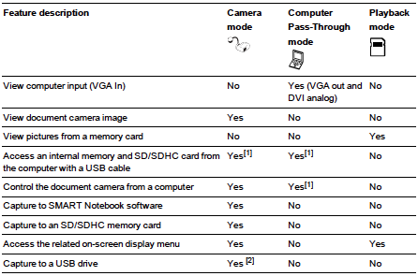

Youtube Document Camera Exploration & Training Clips:

http://www.youtube.com/watch?v=mVlo1OhPi68

http://www.youtube.com/watch?v=zcGn78PV52w

Smarttech Comprehensive User Guides:

Document Camera 330:
http://downloads01.smarttech.com/media/sitecore/en/support/product/smartdocumentcamera/sdc330/guides/guidedoccamera330usersv22feb12.pdf

Document Camera 450:
http://downloads01.smarttech.com/media/sitecore/en/support/product/smartdocumentcamera/sdc450/guidesmartdocumentcamera450v23jan13.pdf

